## Visits by U.S. nuclear attack submarines to HMAS Stirling, Western Australia, 1976 - March 1982

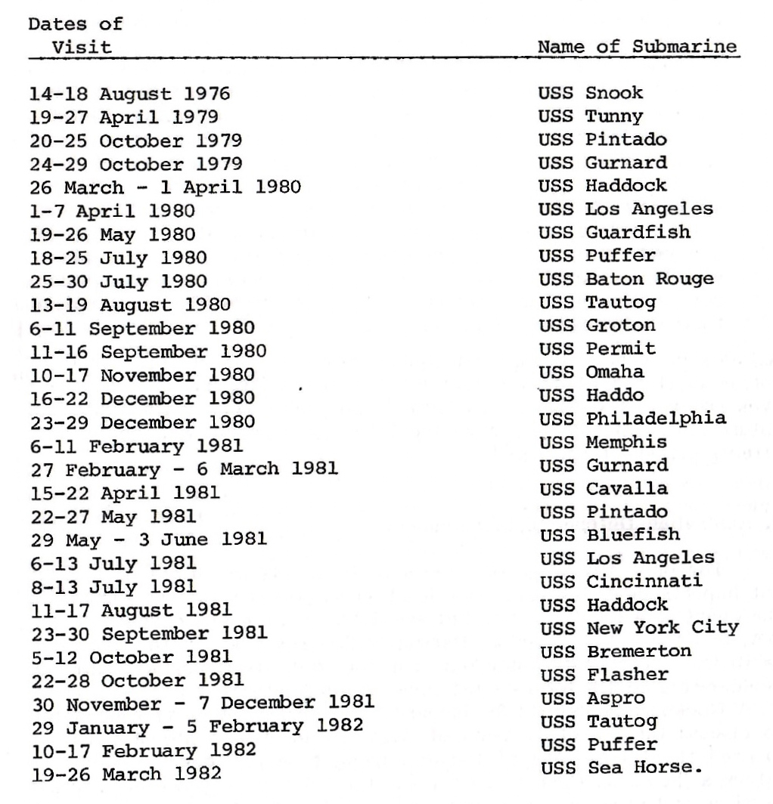

Source: Desmond Ball, ‘Limiting danger from nuclear attack’, in Desmond Ball and J.O.Langtry (eds.), *Civil Defence and Australia’s Security in the Nuclear Age*, (Sydney: George Allen and Unwin, 1983), p. 154, drawing on CPD, House of Representatives, 22 March 1981, p. 1080; 5 May 1981, p. 2004; 10 June 1981, p. 459; 19 August 1981, p. 459; and 4 May 1982, p. 2226.