Richard Tanter,
‘Evaluating four claims by Brian Toohey against Paul Dibb on Pine Gap’,
20 March 2024
This note examines four key claims BY Brian Toohey in his article “Untruths, the CIA, and Whitlam’s dismissal”, Pearls and Irritations, 14 February 2024, and is an addendum to my response to Toohey:

Richard Tanter, ‘Mystifying Pine Gap – again – Brian Toohey on Paul Dibb’s ‘astonishing’ errors’, Pearls and Irritations, 21 March 2024.

In January 2021, I wrote at greater length on similar claims by Toohey in his 2020 book Secrets:

Richard Tanter, ‘Mystifying Pine Gap, Distorting Des Ball: Notes on Brian Toohey’s Secret: The Making of Australia’s Security State‘, Nautilus Institute, NAPSNet Policy Forum Online, 11 January 2021 [with a response by Brian Toohey].

1. Toohey on Herbert Scoville:

Toohey: ‘Contrary to Dibb’s account, Pine Gap had almost no role in checking on Soviet compliance with the counting rules in the various strategic arms limitation agreements. A former deputy director of the CIA Herbert Scoville, among others, has convincingly explained that photo surveillance satellites in low earth orbit were the crucial verification tools.’

Comment:
In his book Secrets, Toohey presented an account of Scoville’s 1979 remarks in more detail, again with the aim of dismissing any suggestion that Pine Gap’s signals intelligence capabilities played any role in verification of the SALT I and SALT II agreements.

In Mystifying Pine Gap I looked at what Toohey reported Scoville as saying, and came away unconvinced by Toohey for a number of reasons.

In the 1979 two-page New York Magazine article cited by Toohey, Scoville was primarily concerned to assuage the Senate’s ‘hesitancy’ to ratify the SALT II treaty after the loss of access to Soviet telemetry from listening stations in Iran after the overthrow of the Shah. Scoville sought to calm concerns by stating that the Iranian intercepts, while once important, could be replaced by ‘alternative redundant sources’ to ensure verification needs. Reconnaissance and infrared satellites would locate missiles on Soviet bases, and detect launches.

True, after the Iran loss, telemetry interception ‘will be hampered’, he wrote,

‘until this capability can be replaced with high flying planes, such as the U-2, or by satellites. However, such data is not necessary for answering the key verification questions.’ [RT emphasis]

Firstly, reading Scoville four decades later, there is something strikingly absent from his quick tour of the intelligence sensor horizon: except for the highlighted word in the last quotation, there is no mention of American signals intelligence satellites in Scoville’s list, even to dismiss their salience for the SALT II treaty.

This may seem odd today when so much is known about them. Yet only the 1977 espionage trial of Christopher John Boyce (and the subsequent 1979 book The Falcon and the Snowman by Robert Lindsey) revealed to the US public (and through Toohey and his colleagues, to the Australian public) the existence of the RHYOLITE satellites, some of their capabilities, and their ground stations.

There was to be no official US acknowledgement of the geosynchronous signals intelligence until 1996. In fact, throughout the 1970s SALT II negotiation and ratification process there was a fierce debate in the White House, Pentagon, State Department and the intelligence agencies about declassification of any space-based intelligence collection capabilities.

The State Department, CIA, and the Arms Control and Disarmament Agency were in at least partial support of declassification, at least for reconnaissance photographic satellites.

Kissinger and the NSA strongly opposed declassification, especially of space-based communications intelligence, because, as the Director of the NSA argued in 1976, this was ‘an area in which we believe the Soviets have little or no knowledge’.

While the Carter Administration partially declassified ‘the fact of’ photographic satellite reconnaissance in 1978 – thus allowing Scoville to write of it a year later – it was to be another two decades before President Clinton declassified ‘the fact of’ signals intelligence satellites in 1996.

In other words, Scoville’s carefully-worded 1979 statement reflected the very limited range that a supporter of one side of this secret bureaucratic struggle could discuss in public. Hence, just a one-word mention of possible future signals intelligence ‘satellites’ in the quotation above.

For me, the decisive document is the National Security Agency’s 500 page secret official history of its work and bureaucratic struggles (especially with the CIA) declassified as American Cryptology during the Cold War, written by the NSA historian Thomas Johnson. In the case of SALT II negotiations, the NSA history makes clear that the idea that overhead imagery alone could not do the job for the complex verification requirements of SALT II:

‘How, for instance, would verification determine how many warheads a MIRVed missile carried? Photography could not see into the missile silo... There were similar rules defining types of missiles, depending largely on range and payload, and these depended on SIGINT for verification. Telemetry from missile tests was vital to determine both facts and, on occasion indicated that new missile capability might exceed the limits (prohibited in the draft treaty) or simply be a modification of an older type (permitted)...’
Eventually, so critical was the role of signals intelligence (amongst other National Technical Means) for verification of SALT II, the treaty’s formal ‘common understandings’ explicitly prohibited denial of telemetric information needed for verification.

2. Toohey and Dibb on CIA station chief in Australia in 1975

Toohey: “Dibb failed to acknowledge that Wonus was the Canberra CIA station chief in November 1975.’

Dibb: “The working knowledge I have of this [Kissinger’s ‘appreciation’ of the role of Pine Gap and arms control agreements] and was from Corley Wonus who was the CIA Station Chief in Canberra in the late 1970s when I was head of the National Assessments Staff working for the National Intelligence Committee. He was the senior American intelligence officer in Australia in charge of running Pine Gap.’

As Desmond Ball, Bill Robinson, and I discussed in our 2015 study of The Higher Management of Pine Gap, Wonus was the CIA Station Chief in Canberra in 1975-80, Director of the CIA’s Office of Technical Service in 1980-1984, and the Director of the Office of SIGINT Operations from 1984 to 1989.

In each of these three posts working towards the top of the CIA’s Deputy Directorate of Science and Technology, Wonus was at the centre of the CIA’s signals intelligence operations during the Second Cold War period, for which Pine Gap was the crown jewel. Very few people in the world knew more about Pine Gap.

3. Dibb and Toohey on why the Pine Gap facility was located in the middle of Australia:
Dibb: ‘This was because the signals from the satellite were so tiny that the collection facility had to be surrounded by a huge area that was electromagnetically almost completely silent. Pine Gap was one of very few locations in the world that had such critical characteristics.

‘Moreover, Pine Gap’s satellite operations centre was very well positioned to manage the physical task of ‘re-bore sighting’ (retargeting) of the Rhyolite satellite on new Soviet military intelligence targets. This demanding operational task was enhanced because the Siberian landmass, where most Soviet operational nuclear missiles were located, was directly to the north of Pine Gap.
‘In addition, the location of Pine Gap had to be free from the threat of interception on the ground. This was because the downlink signals were unencoded at that time. Encoding them, I was told, would have made these tiny signals even more difficult to receive. Wonus reassured Kissinger that ASIO would continue to prohibit any members of the Soviet embassy from visiting Alice Springs.’
Toohey:
‘[Defence Minister 1966-69 Allen] Fairhall said the station would occupy 50 acres and be “surrounded by a 10 square mile ‘buffer zone’ to reduce electrical interference”. That’s a lot less than Wonus was talking about. There is no reason to believe the US government deliberately underestimated how large the buffer zone would need to be. This figure is broadly in line with the small buffer zone that surrounds other facilities such as the big satellite station at Menwith Hill in a narrow part of England.
‘The growing city of Alice Springs, with a population of over 26,000, is only 18 km from Pine Gap, continues to expand. Pine Gap is also growing strongly. It’s not plausible that the huge buffer zone stressed by Wonus was really needed. In any event, the US has constantly developed larger and more powerful antennae for its satellites to intercept and download signals.’

Comment:
Here Toohey confuses two separate technical requirements that influenced the original location of Pine Gap.

One is the minor matter of a ‘buffer zone’ to reduce electrical interference – 10 square miles in the 1960s, according to Toohey’s recall. That is roughly the size of the prohibited zone around Joint Defence facility Pine Gap today (or Menwith Hill).

All major electronic transmitting and receiving stations in Australia today are monitored and regulated by the Australian Communications and Media Authority to limit interference between stations. A number of Pine Gap’s antennas are listed as subject to ACMA regulation, and anyone wanting to locate a serious transmitter close to Pine Gap would be scrutinised closely by both ACMA and ASIO, though for different reasons.

Toohey jumbles this issue with the much more historically determinative matter facing the CIA in 1966: how could the Soviet Union be prevented from simply locating a receiver close to enough to Pine Gap to intercept and monitor the very weak signals transmitted from a Rhyolite satellite 36,000 kilometers above the equator – signals that were at that time unencrypted?

From how big an area did Soviet spy antennas have to be excluded? The answer given at that time by Desmond Ball was 160 km. in diameter - a matter of physics and the electronic technological capabilities of the day.

The size of the area that needs to be secured against adversary interception is, Ball wrote, a function of the transmission frequency and the diameter of the downlink antenna on the satellite. When the geosynchronous SIGINT satellite constellation was planned in the mid-1960s, these were about 24 GHz and 2.5 m. respectively, yielding a requirement of a secure area of about 160 km in diameter. Accordingly, downlinking to small islands such as Diego Garcia or Guam would have been too vulnerable to interception by Soviet SIGINT-equipped ships or aircraft, and crowded land areas in the Philippines or Japan unable to be protected against covert interception system in nearby areas.

The same technical requirements led to the extraordinary size requirements of the first two antennas at Pine Gap to receive and transmit commands to Rhyolite satellites built in 1968. In our study Antennas of Pine Gap, we identify the first built as Antenna 68-A, with a diameter of about 26 metres, covered by a radome of 38 metres in diameter. The second antenna, 68-B, was smaller, with a radome 20 metres in diameter.

Both those antennas and radomes remain in operation today.

For purposes of assessing Toohey’s dismissal of Dibb’s explanation regarding the area required to guard against Soviet interception from the ground, roughly speaking the Soviets would have needed a giant antenna of about 20 metres or more in diameter located somewhere in an area 160 kms across, with or without benefit of an even larger and conspicuous radome.

Such a sight would have been pretty noticeable in outback Australia.

And, to address Toohey’s remarks about Pine Gap’s companion station at Menwith Hill in densely populated, highly landscaped Yorkshire and across 160 kms of the surrounding counties of northern England, even more so.

Figure 1. No hiding place: 160 km diameter circle from Menwith Hill
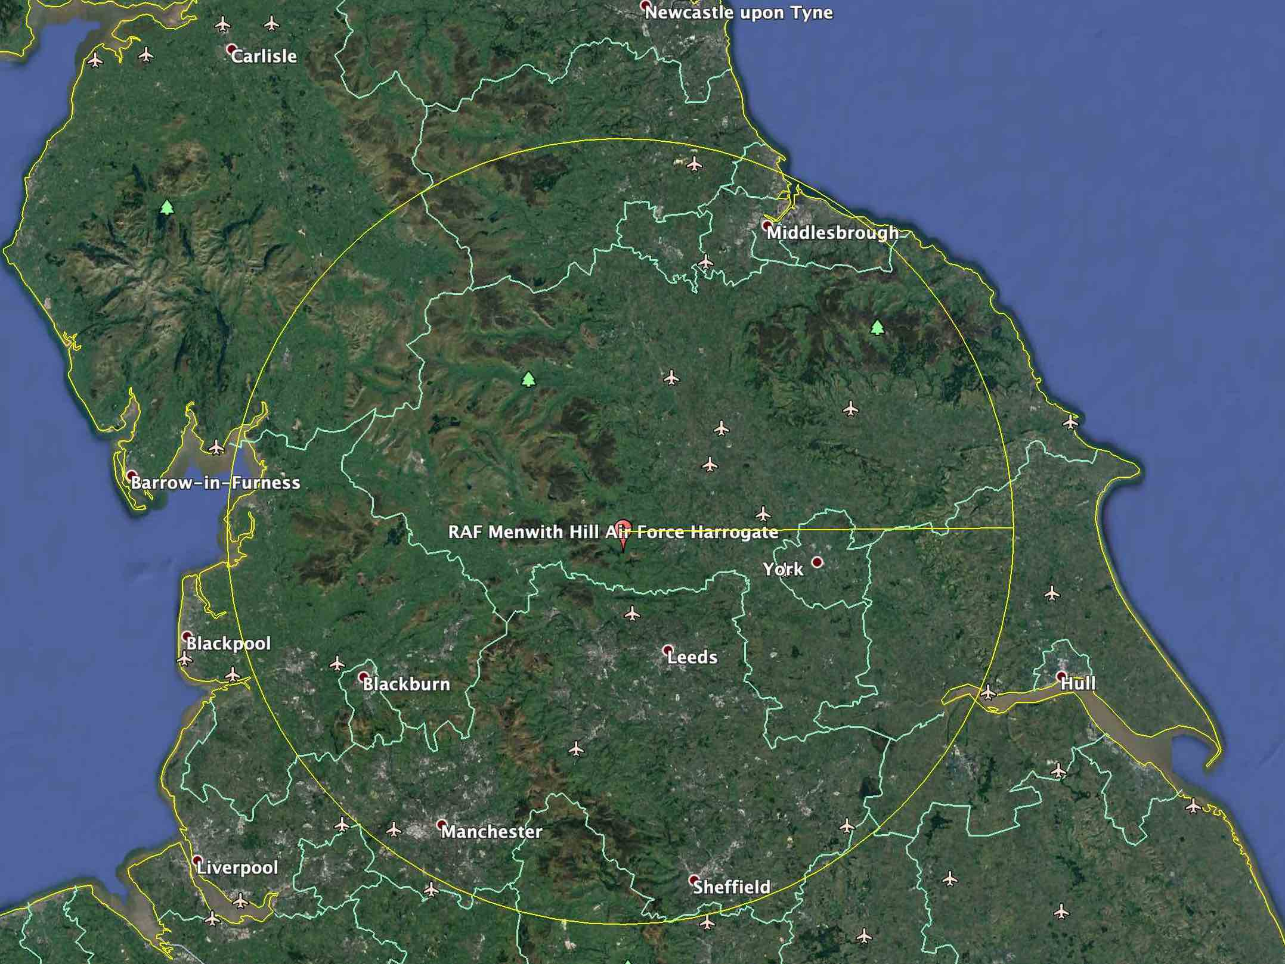
Today, the technical requirements are quite different: smaller receiving antennas on the ground are viable in many cases; US Advanced ORION geosynchronous satellites have more and larger antennas, and more powerful electrical capacities; the rockets to lift them into orbit are more powerful and the satellites much heavier; and there is plenty of capability to richly encrypt downlinks and to securely carry out considerable onboard data processing before downlinking.

https://nautilus.org/wp-content/uploads/2024/03/Richard-Tanter-‘Evaluating-four-claims-by-Brian-Toohey-against-Paul-Dibb-on-Pine-Gap-20-March-2024-v2.docx.
Herbert Scoville Jr., 'The SALT Debate: Why We Don't Need Iran', New York Magazine, Vol. 12, No. 25, 18 June 1979, pp. p. 41-42.
Jeffrey Richelson (ed.), Declassifying the “Fact of” Satellite Reconnaissance, National Security Archive Electronic Briefing Book No. 231, 1 October 2007.
Thomas R. Johnson, American Cryptology during the Cold War, 1945-1989. The Complete Declassified Official Four-Volume History of the NSA Book III: Retrenchment and Reform, 1972-1980, (Center for Cryptologic History, National Security Agency / Red and Black Publishers, 1995), pp. 410-411. Also available, with slightly different redactions) in American Cryptology during the Cold War, 1945-1989. Book III: Retrenchment and Reform, 1972-1980, Center for Cryptologic History, National Security Agency, 1998, pp. 203-204, at https://www.nsa.gov/portals/75/documents/news-features/declassified-documents/cryptologic-histories/cold_war_iii.pdf.
Desmond Ball, Bill Robinson and Richard Tanter, The Higher Management of Pine Gap, Nautilus Institute, Special Report, 18 August 2015, pp. 13-14.
Drawn from Richard Tanter, The “Joint Facilities” revisited – Desmond Ball, democratic debate on security, and the human interest, Special Report, Nautilus Institute for Security and Sustainability, 12 December 2012, p. 46, at https://nautilus.org/wp-content/uploads/2012/12/The-_Joint-Facilities_-revisited-1000-8-December-2012-2.pdf.

