  - Photo Essay: Landscapes of Secret Power
  - Photography by Kristian Laemmle-Ruff, Trevor Pagan, and Felicity Ruby
  - Text: Richard Tanter

  - Arena Magazine, May-June 2017

This footnoted version is available at http://nautilus.org/network/associates/richard-tanter/publications/.
Note: erratum at footnote 9.

Pine Gap and Menwith Hill are the two largest US intelligence stations on foreign soil, the jewels in the crown of the Five Eyes coalition of the United States and Britain (First Parties), and Australia, Canada and New Zealand (Second Parties). Despite this collaboration since 1947 and the more recently deployed fig-leaf term ‘joint facilities’, this transnational intelligence community is a US-auspiced, -constructed and -directed global hierarchy, closely integrated into US military operations worldwide, and an exemplar of US-led military globalisation.

Like its English counterpart, Pine Gap, with its thirty-three antenna systems, epitomised by the white radomes protecting nineteen of them from both a harsh environment and prying eyes, is in fact vastly more than its antennas, or even the intelligence-collection activities of the satellites linked to those antennas. The antennas are the visible incarnations of a globe-encircling web of optical-fibre- and satellite-communication systems, in turn linked to a dense network of US military-intelligence processing, analysis and computing sites. We face difficulty in comprehending and representing the nature of the operations of even something as materially palpable as Pine Gap or Menwith Hill, given the density of their activities, the intensity of their computer processing and data exchange, and the multiple scales of their operations, ranging from deep space to geo-location with metre-level precision across half the world.

Three artists—Kristian Laemmle-Ruff, Trevor Paglen and Felicity Ruby—present us with landscapes of Pine Gap and Menwith Hill, to inform and to disturb. Trevor Paglen is a geographer, artist and technical innovator in photography, and the author of Blank Spots on the Map and Invisible: Covert Operations and Classified Landscapes. His Menwith Hill series are interrupted English pastorals. The benign familiarity (to an Australian colonial audience) of Yorkshire village houses is ambushed by a row of faintly visible radomes, alien in every sense.

Felicity Ruby, an Australian researcher, has been documenting Five Eyes surveillance sites in numerous countries. Her photographs here are the fruit of doing the obvious with what is in plain sight: hiring a helicopter and (legally) circling outside the prohibited zone. Her landscape long shots contrast in colour and form to Paglen’s Yorkshire; they depict a differently beautiful but harder landform far less made over by human hand—until, in the far distance, Pine Gap can be seen, like an island translated from a strange land.

Kristian Laemmle-Ruff, a Melbourne artist, musician and photographer, set himself the task of finding a location never before used for surveilling Pine Gap, waiting for moonrise to pick his way through rocky hills as the beams of the patrol cars cut the night air. His goal was both art and information, taking photographs of unprecedented quality and precision of all parts of the base. Laemmle-Ruff’s pre-dawn panorama of the entire facility has a diabolical beauty, the foliage on the edge of the shot and the gentle hills of Kyunba behind the base enticing the viewer, until awareness of the unnaturalness of the scene returns.

As massive and highly sophisticated military infrastructure, Pine Gap and its like challenge our normal notions of landscape photography, of the companionable and legible relation between material reality and its representation that photography appears to promise. There are multiple materialities involved, the most important either hidden within the facilities, illegible to non-specialists, or literally invisible. Geographers have been thinking a lot recently about both the US empire of bases and the elusive solution to analysing and representing a globally distributed, materially heterogenous landscape of digital technology, much of which exists in an invisible Hertzian landscape constituted by the electromagnetic spectrum operated through all-too-material antennas, advanced computing facilities, sensors, data banks, communications satellites and globe-spanning webs of dedicated optical fibre.

[Another artist has tried to render illegible military technologically legible—in this case, drones. Writing of representations of the high technologies of contemporary war, Bridle says:

It is impossible for me…not to look at these images and immediately start to think about not what they look like, but how they came to be and what they become…the processes of capture, storage, and distribution; the actions of filters, codecs, algorithms, processes, databases, and transfer protocols; the weight of data centres, servers, satellites, cables, routers, switches, modems, infrastructure physical and virtual; and the biases and articulations of disposition and intent encoded in all these things, and our comprehension of them.]

These are depopulated landscapes, without images of people. The land was excised from public access for use by the foreign power long ago—1957 in the British case, and a decade later in the Australian. There was no thought in Canberra in 1965–66 of the Arrernte custodians, for whom the Kyunba land is deeply alive. They, along with government members of the Australian parliament, were long denied access to the sacred sites of Pine Gap (though not so visiting members of the US Congress).

Pine Gap is an example of a high-technology, low-population-density ‘strategic island’ (albeit land bound in this case) within entangled strategic geographies and spatialities of imperial transnationalisms. Those who work at Pine Gap and Menwith Hill—US military personnel, Australian military and defence officials, and corporate employees of Raytheon, Northrop Grumman or Lockheed Martin—are part of largely transnational and transient communities.

Pine Gap is an island in other ways, with a measure of denationalisation accompanied by a reterritorialisation as part of a complicit node of empire. There is nothing comparable to Pine Gap’s combination of physical size, raw computing power, and level and depth of electronic integration into wider patterns of surveillance-information exchange, stored within a thousand kilometers of Alice Springs. And yet it is separated from the rest of the American military-base archipelago not by space but only by the passage of the speed of light carrying bits of information down the optical-fibre threads of what the US military is pleased to call the Global Information Grid.

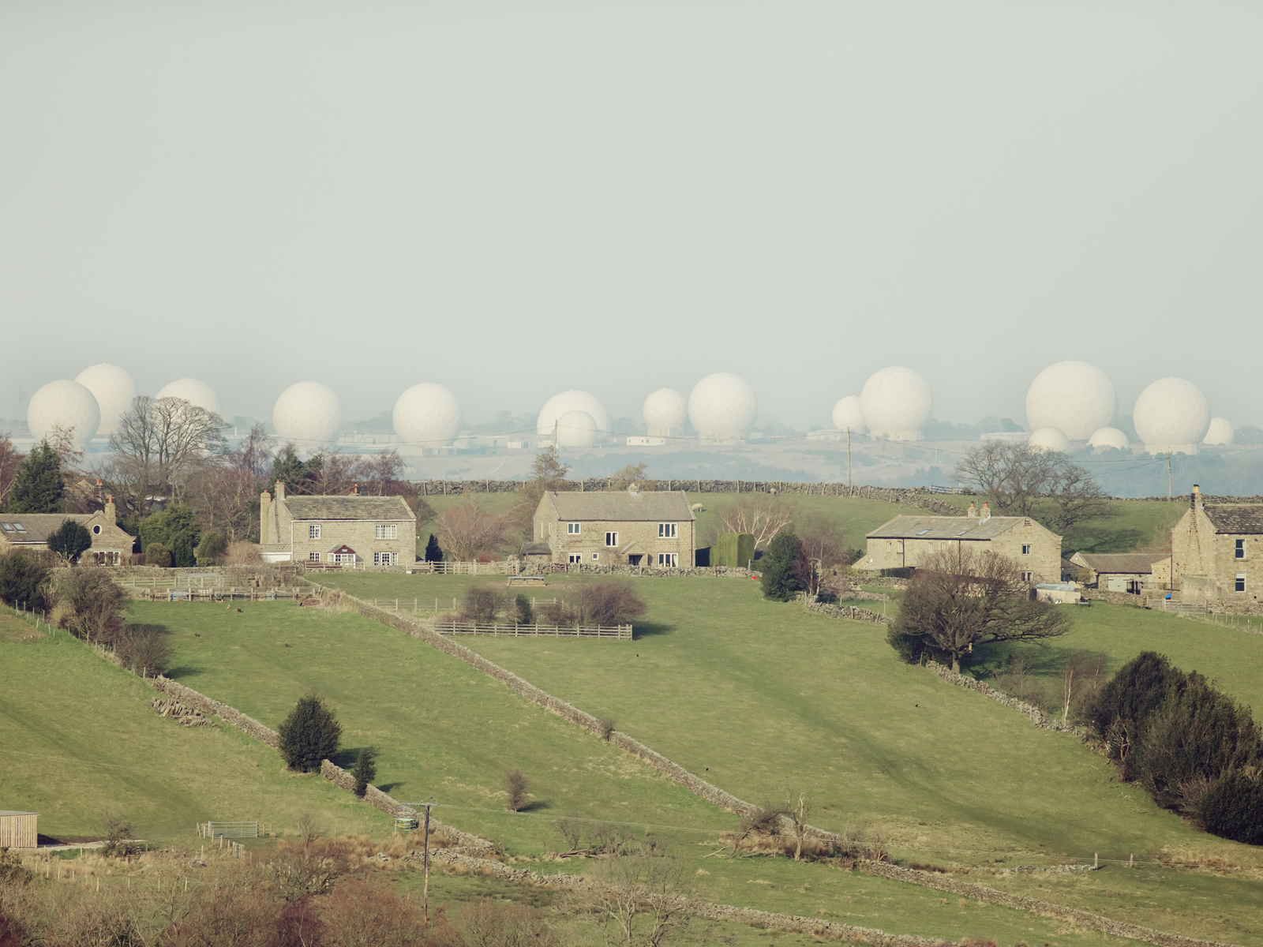

Trevor Paglen, Menwith Hill, March 13, 2013.

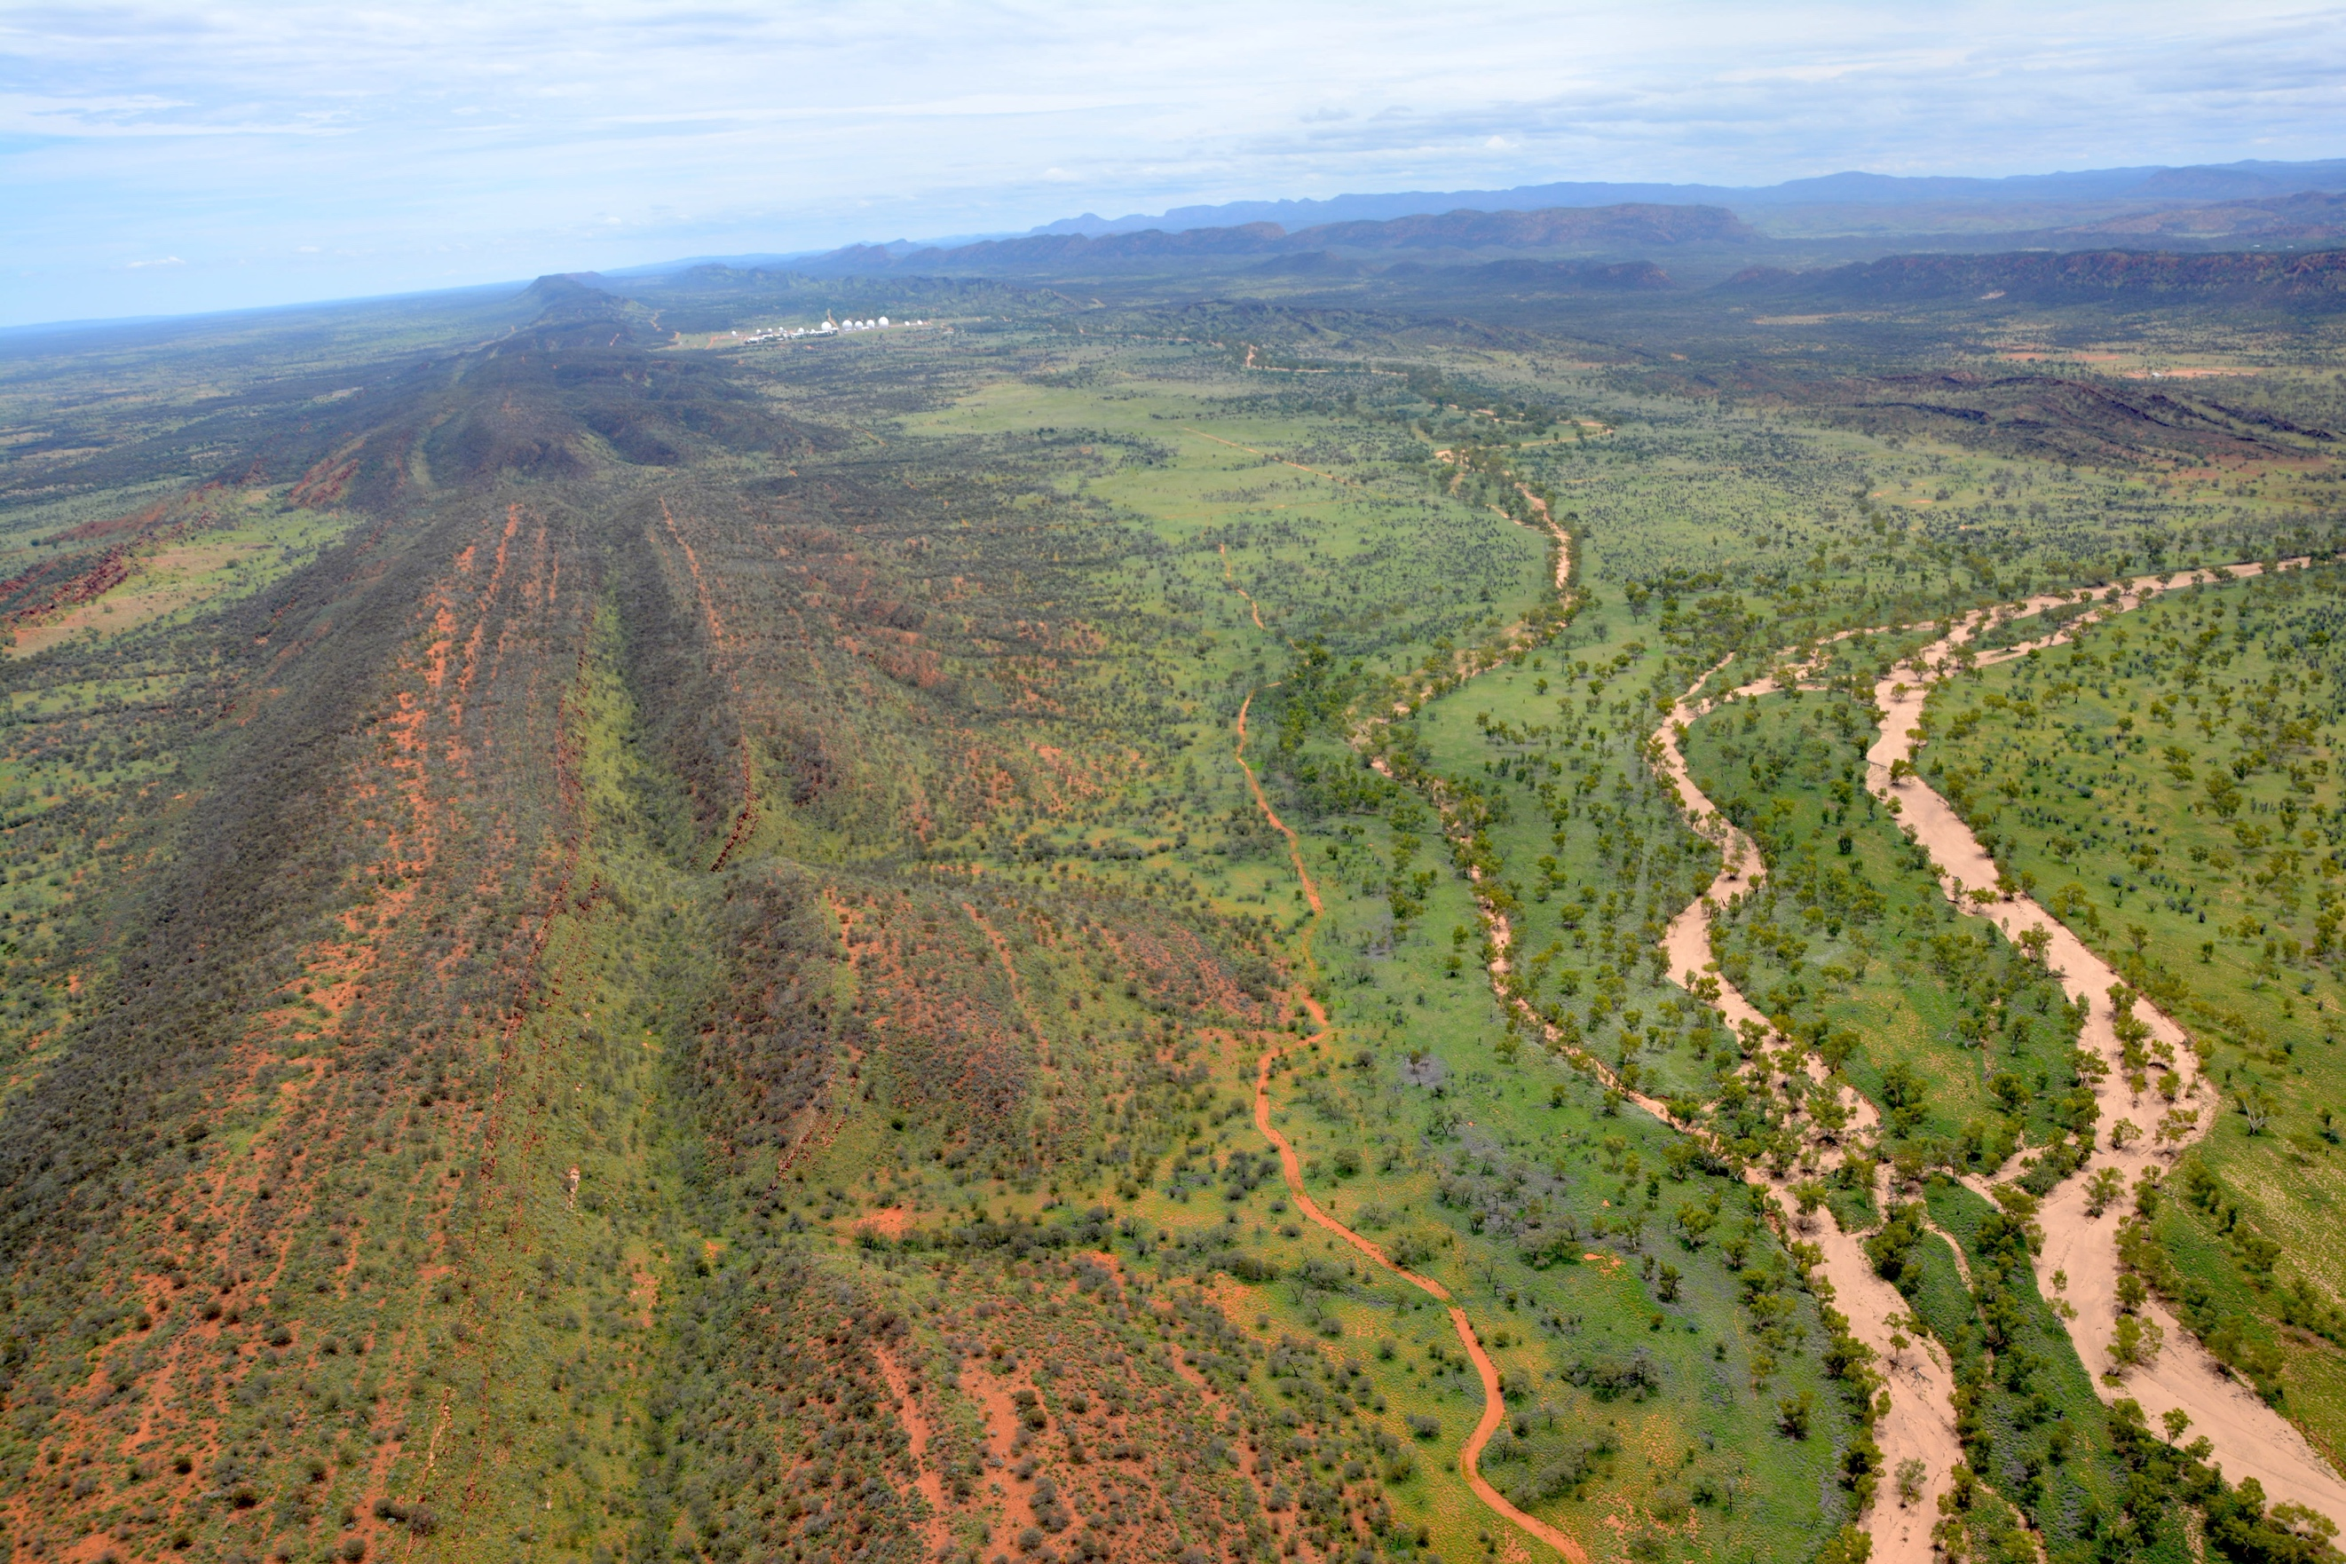

Felicity Ruby, Pine Gap, 23 January 2016

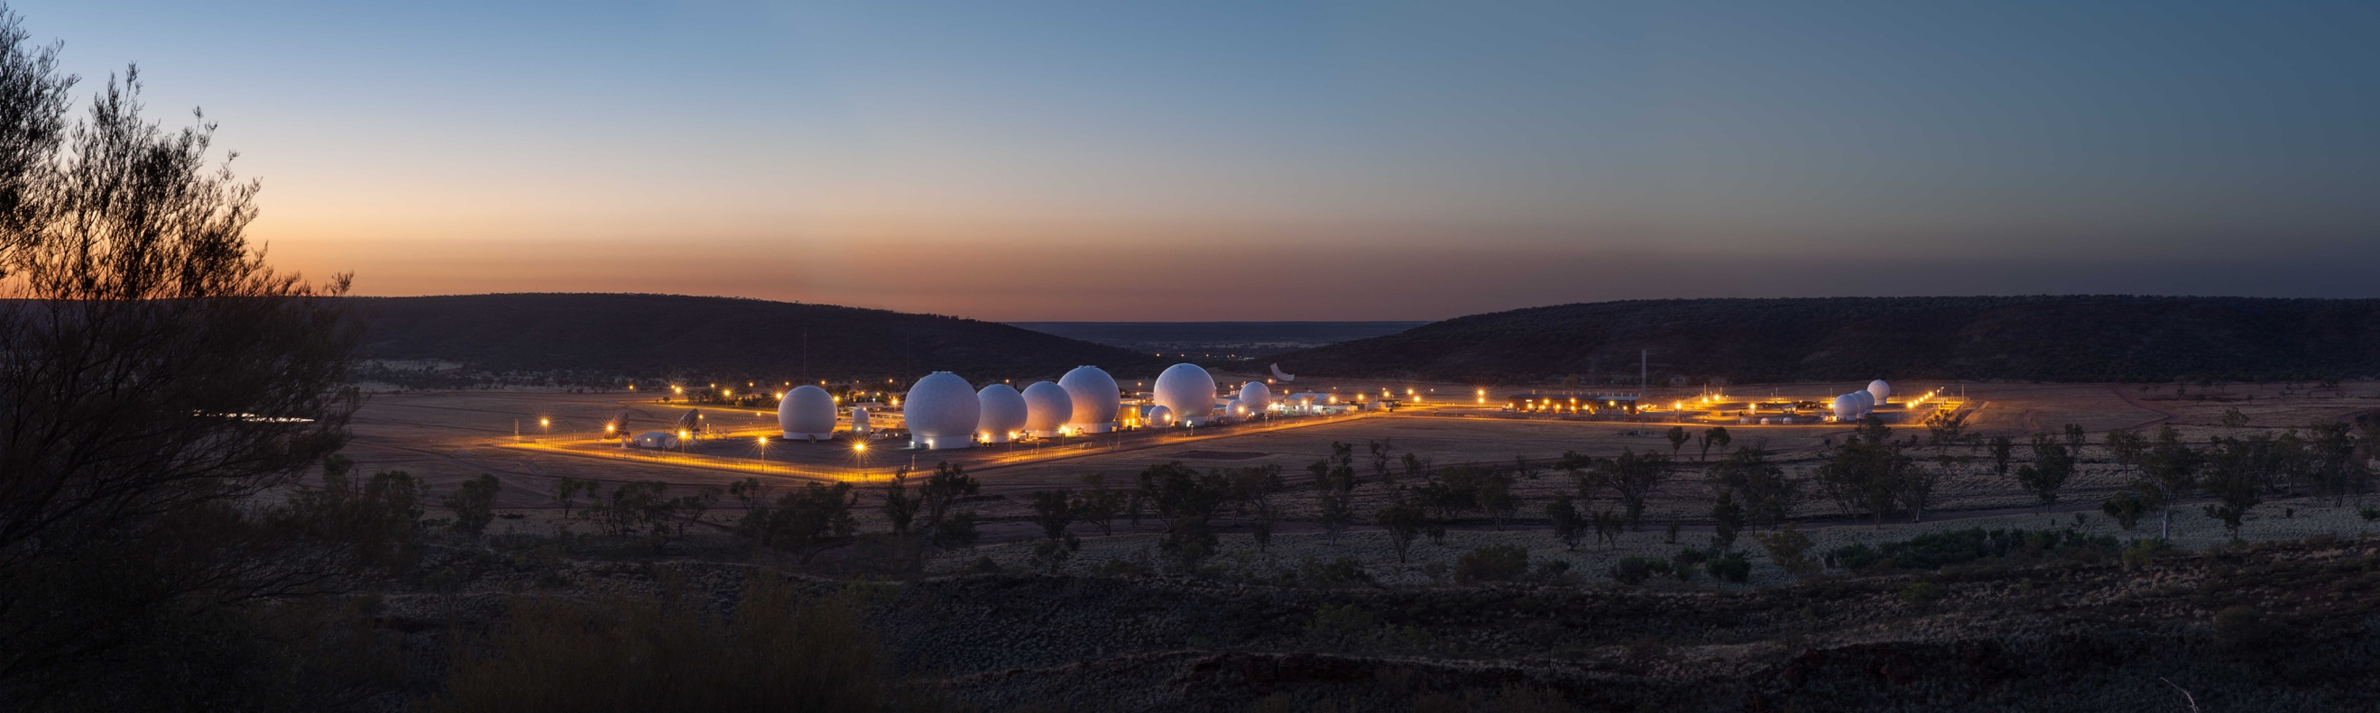

Kristian Laemmle-Ruff, Pine Gap

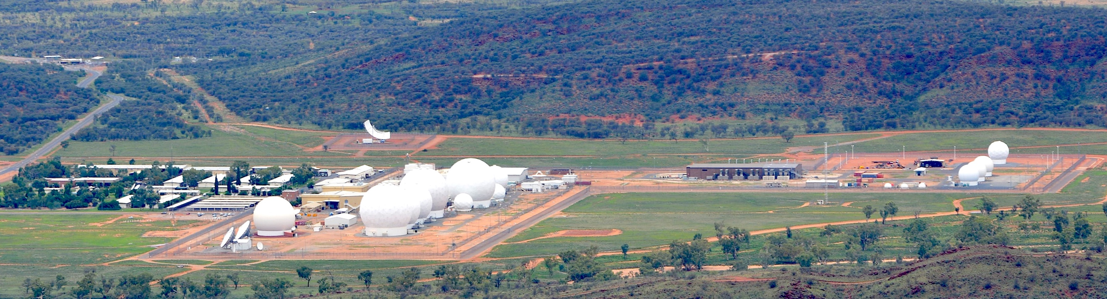

Felicity Ruby, Pine Gap, 23 January 2016

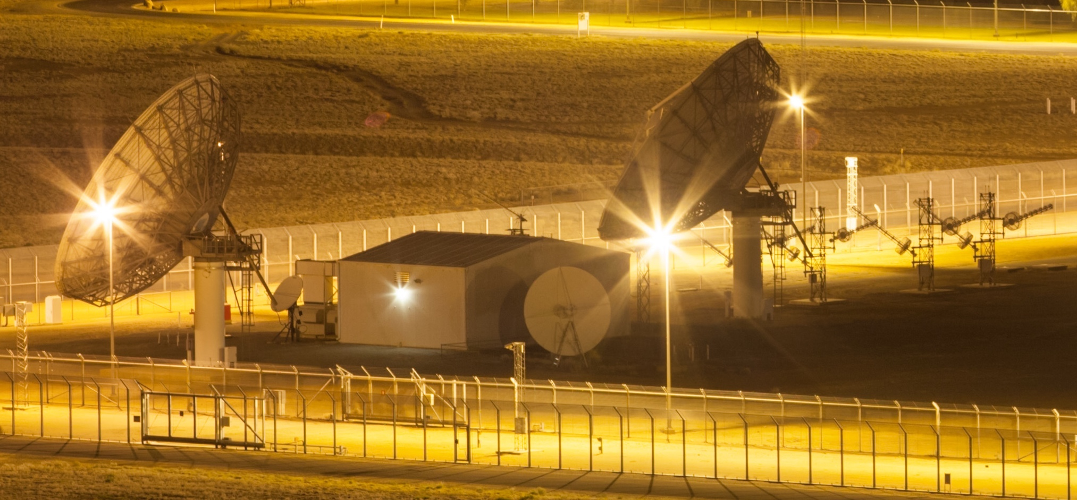

Kristian Laemmle-Ruff, Pine Gap DSP/SBIRS communications antennas
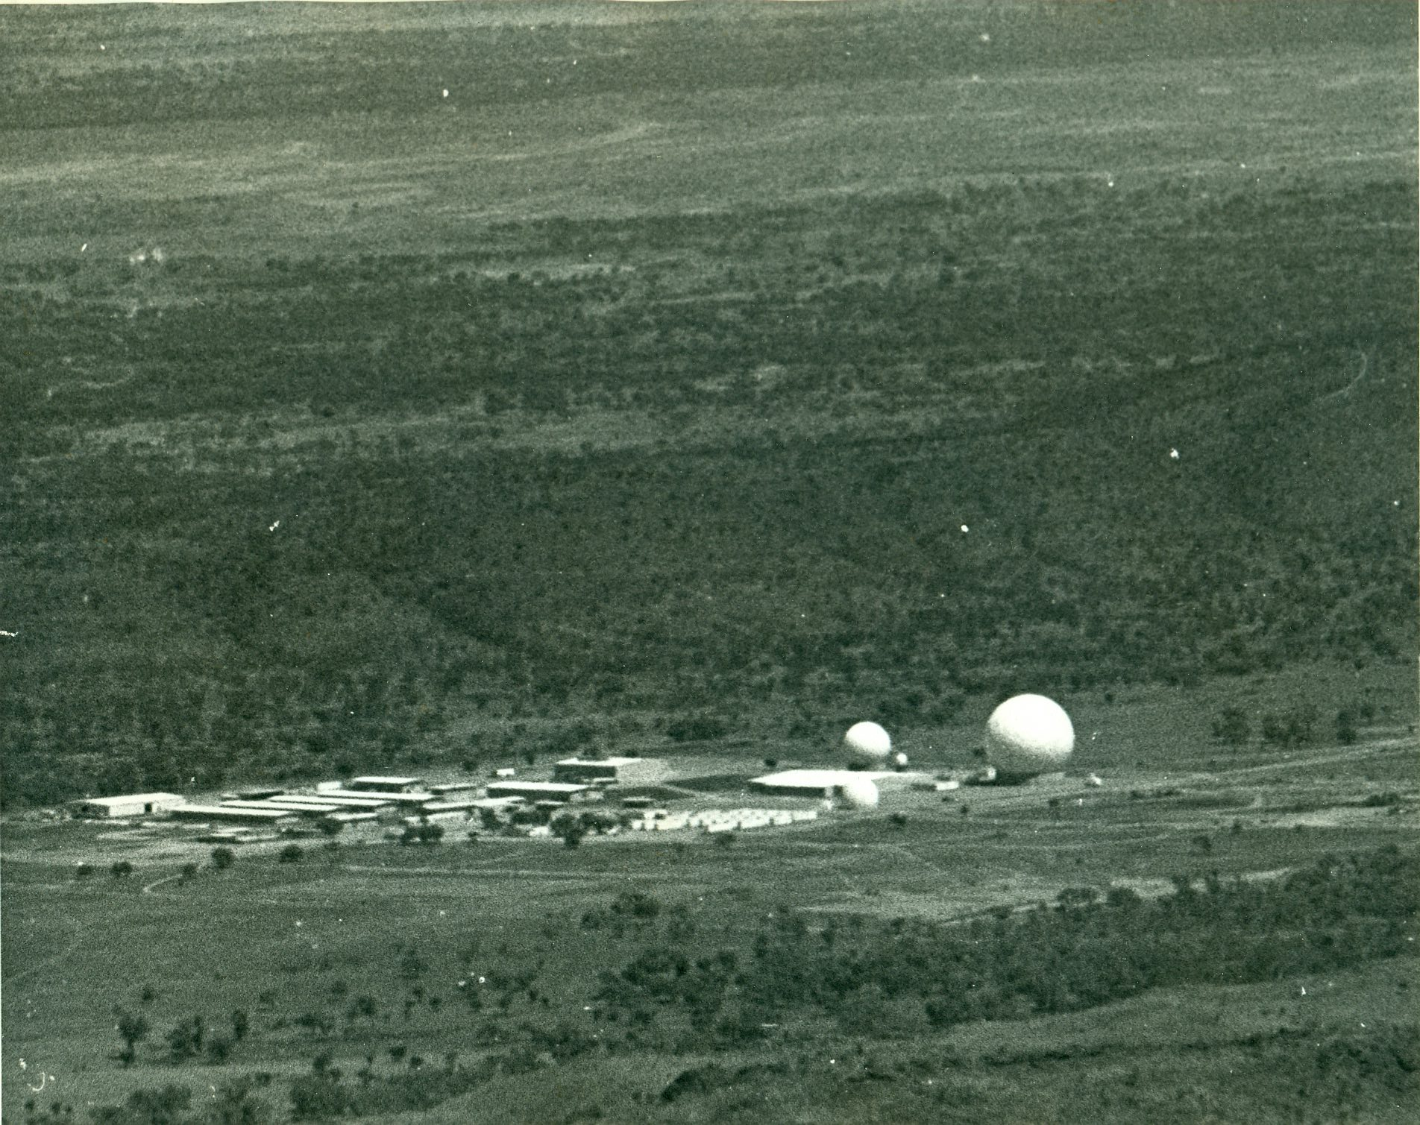

Desmond Ball, Pine Gap, 1969

On Five Eyes and the UKUSA agreements see Desmond Ball, Duncan Campbell, Bill Robinson and Richard Tanter, Expanded Communications Satellite Surveillance and Intelligence Activities Utilising Multi-beam Antenna Systems, Nautilus Institute, Nautilus Institute, Special Reports, 28 May 2015, p. 70. http://nautilus.org/wp-content/uploads/2015/05/Torus-SATCOM.pdf.
On Pine Gap see Richard Tanter, ‘Our poisoned heart: the transformation of Pine Gap‘, Arena Magazine, No. 144, October 2016; and the research papers by Desmond Ball, Bill Robinson, Richard Tanter and other colleagues published by the Nautilus Institute collected at the Pine Gap Project: http://nautilus.org/briefing-books/australian-defence-facilities/pine-gap/the-pine-gap-project/.
See Desmond Ball, Bill Robinson and Richard Tanter, The Antennas of Pine Gap, Nautilus Institute, Special Reports, 22 February 2016 at http://nautilus.org/napsnet/napsnet-special-reports/the-antennas-of-pine-gap/. That paper contains an antenna identification chart and photokey.
See Trevor Paglen’s website at http://www.paglen.com/.
Felicity Ruby, Five Eyes, at https://felicityruby.com/five-eyes/. ‘Felicity Ruby images of Pine Gap’, Australian Defence Facilities Pine Gap, Nautilus Institute, 21 February 2016, http://nautilus.org/briefing-books/australian-defence-facilities/felicity-ruby-images-of-pine-gap-2/.
See Laemmle-Ruff’s website at https://www.kristianlaemmleruff.com/; and ‘Kristian Laemmle-Ruff images of Pine Gap’, Australian Defence Facilities Pine Gap, Nautilus Institute, 19 February 2016, http://nautilus.org/briefing-books/australian-defence-facilities/kristian-laemmle-ruff-images/.
See for example, Ruth Oldenziel, ‘Islands: The United States as a Networked Empire’, in Gabrielle Hecht (ed.), Entangled Geographies: Empire and Technopolitics in the Global Cold War, MIT Press, 2011, pp. 13-42; Pierre Belanger and Alexander Arroyo, Ecologies of Power: Countermapping the Logistical Landscapes and Military Geographies of the U.S. Department of Defense, MIT Press, 2016; and Mel Hogan, ‘Data flows and water woes: The Utah Data Center’, Big Data & Society, July–December 2015: 1–12.
James Bridle, “The New Aesthetic and its Politics”, booktwo.org, 12 June 2013, at http://booktwo.org/notebook/new-aesthetic-politics/. Note: these paras were omitted from the print version of this article.
L. Kyle Napton and E.A. Greathouse, ‘Archaeological investigations at Pine Gap (Kuyunba), Northern Territory’, Australian Archaeology, (1985) 20:90-108.
Erratum: In the Arena Magazine print edition of this essay, this sentence read ‘They, along with government members of the Australian parliament, have long been denied access to the sacred sites of Pine Gap (though not so visiting members of the US Congress).’
An Agreement to extend the period of operation of the Joint Defence Facility at Pine Gap, Joint Standing Committee on Treaties, Parliament of the Commonwealth of Australia, October 1999, paras 2.6-2.9. Subsequently Australian members of parliament have been allowed to visit certain areas of the facility.
On ‘strategic islands’ and United States basing strategy, see Ruth Oldenziel, ‘Islands: The United States as a Networked Empire’; and David Vine, Island of Shame: The Secret History of the U.S. Military Base on Diego Garcia, Princeton U.P., 2009, pp. 56-71.
See Desmond Ball, Bill Robinson and Richard Tanter, The militarisation of Pine Gap: Organisations and Personnel, Nautilus Institute, Special Report, 14 August 2015, at http://nautilus.org/wp-content/uploads/2015/08/The-militarisation-of-Pine-Gap.pdf; Desmond Ball, Bill Robinson, Richard Tanter and Philip Dorling, The corporatisation of Pine Gap, Nautilus Institute, NAPSNet Special Reports, 24 June 2015, at http://nautilus.org/wp-content/uploads/2015/06/The-corporatisation-of-Pine-Gap.pdf; and Desmond Ball, Bill Robinson and Richard Tanter, Managing Operations at Pine Gap, Nautilus Institute, Special Reports, 24 November 2015, at http://nautilus.org/wp-content/uploads/2015/11/PG-Managing-Operations-18-November-2015.v2.pdf.
See, for example, the work of Saskia Sassen on movements of denationalization and reterritorialisation within processes of globalisation in her Territory, Authority, Rights: From Medieval to Global Assemblages, Princeton U.P, 2006, and elsewhere.

